

PROJECT REPORT
AI Lecture Notes Generator
A Locally-Run AI System for Converting Lecture Audio into
Structured, Exportable Notes
Submitted by:
Abdullah Adnan
Class ID: CU-5230-2024 / 1121
Class Code: BSSE-2024B
Subject: Artificial Intelligence
Program: BS Software Engineering (4th Semester)
Submitted to: Mam Manahil Ather

Abstract
Manually transcribing and summarizing spoken lectures is a time-consuming task that often distracts students from actively engaging with the material being taught. This project, the AI Lecture Notes Generator, addresses this problem by presenting a fully local, AI-driven system that automatically converts recorded lecture audio into structured, readable notes without relying on any external cloud-based application programming interfaces (APIs).
The system integrates two artificial intelligence models that run entirely on the user's own machine. The first is OpenAI's Whisper model, used in its open-source local form for automatic speech recognition, converting spoken audio into raw text transcripts. The second is Facebook's BART (Bidirectional and Auto-Regressive Transformer) model, which was fine-tuned by the author on a custom-built dataset of twenty-five artificial intelligence lecture excerpts paired with hand-written summaries. This fine-tuning step represents the core training component of the project, satisfying the requirement that students train their own model rather than depend on a third-party AI service.
Beyond the AI pipeline, the project includes a custom notes-formatting module that converts raw summaries into structured notes containing a topic title (generated automatically when not supplied by the user), a list of key points, and a set of extracted key terms relevant to artificial intelligence and machine learning. The entire system is wrapped in a web application built using the Flask framework, providing a clean, accessible interface where users can drag and drop an audio file, optionally specify a topic, and receive formatted notes that can be exported as a text file.
The final product demonstrates that a complete, locally-executable AI pipeline -- spanning speech recognition, natural language processing, model fine-tuning, and web deployment -- can be built and trained by a single fourth-semester student within a structured timeframe. The report that follows documents the objectives, design decisions, development process, challenges encountered, and results achieved throughout the project.

Acknowledgement
I would like to express my sincere gratitude to my course instructor, Mam Manahil Ather, for her guidance and for encouraging a shift in this project's direction toward locally-trained artificial intelligence models. This requirement, while initially challenging, ultimately resulted in a deeper and more meaningful learning experience than the originally planned API-based approach would have provided.
I am also grateful to CECOS University of IT and Emerging Sciences, Peshawar, for providing the academic environment and resources that made this project possible. Finally, I would like to acknowledge the open-source community behind OpenAI Whisper and the HuggingFace Transformers library, whose freely available tools and pre-trained models formed the foundation upon which this project was built.

Table of Contents
Abstract 1
Acknowledgement 1
Table of Contents 1
Introduction 1
Problem Statement 1
Objectives 1
Scope of the Project 1
8.1 In-Scope Features 1
8.2 Out-of-Scope Features 1
8.3 Target Users 1
Literature Review / Existing Solutions 1
9.1 Automatic Speech Recognition 1
9.2 Abstractive Text Summarization 1
9.3 Transfer Learning and Fine-Tuning 1
9.4 Existing Commercial Solutions 1
System Analysis 1
Functional Requirements 1
Non-Functional Requirements 1
System Architecture 1
13.1 Component Description 1
Flask Web Application (app.py) 1
Speech-to-Text Module (speech_to_text.py) 1
Summarizer Module (summarizer.py) 1
Notes Formatter Module (notes_formatter.py) 1
Fine-Tuning Script (finetune.py) 1
Methodology 1
Technologies Used 1
15.1 Justification of Technology Choices 1
Database Design 1
User Interface Design 1
17.1 Input Section 1
17.2 Loading State 1
17.3 Results Section 1
17.4 Visual Design 1
Project Workflow 1
18.1 Use Case Diagram 1
AI Integration and How the AI Works 1
19.1 Speech Recognition with Whisper 1
19.2 Summarization with Fine-Tuned BART 1
19.2.1 Fine-Tuning Process 1
19.2.2 Verification of Fine-Tuning 1
19.3 Sentence-Aware Chunking 1
19.4 Automatic Title Generation 1
Challenges Faced During Development 1
20.1 Mid-Course Requirement Change: From APIs to Local Training 1
20.2 Virtual Environment Path Errors After Moving the Project Folder 1
20.3 Shell Inconsistencies Between PowerShell and Command Prompt 1
20.4 Deprecated Training Argument in HuggingFace Transformers 1
20.5 Sentence Truncation in Generated Notes 1
20.6 Large Model Files in Version Control 1
20.7 Auto-Generated Title Not Triggering 1
20.8 Browser Caching During Frontend Development 1
Testing and Validation 1
21.1 Speech-to-Text Validation 1
21.2 Summarization Validation 1
21.3 Notes Formatter Validation 1
21.4 End-to-End Pipeline Validation 1
21.5 Web Application Validation 1
21.6 Defect Verification 1
Results and Output 1
22.1 Sample of Fine-Tuning Results 1
22.2 Project Repository 1
Screenshots with Explanations 1
23.1 Main Interface (Input Section) 1
23.2 Loading State 1
23.3 Generated Notes (Manual Topic) 1
23.4 Generated Notes (Automatic Title) 1
23.5 Export Function 1
23.6 Project Repository on GitHub 1
Future Enhancements 1
Conclusion 1
References 1

Introduction
Note-taking is one of the most fundamental activities in academic learning, yet it is also one of the most cognitively demanding. Students attending lectures must simultaneously listen, comprehend, filter important information, and write it down in an organized form -- often at the cost of fully engaging with what the lecturer is saying. As lecture content increasingly moves into recorded and online formats, the opportunity arises to apply artificial intelligence techniques to automate the note-taking process itself.
The AI Lecture Notes Generator is a software system designed to take a recorded lecture (in audio form) as input and produce a structured set of notes as output, without requiring any manual transcription or summarization by the user. The system performs this task entirely on the user's local machine, using artificial intelligence models that are either open-source pre-trained models or models fine-tuned by the author specifically for this purpose.
This project was developed as part of the Artificial Intelligence course in the fourth semester of the Bachelor of Software Engineering program at CECOS University, Peshawar. It began as a concept that would use commercial AI APIs (such as the Claude API and the OpenAI Whisper API) for transcription and summarization. However, following a requirement introduced by the course instructor that students must train their own models rather than rely solely on third-party APIs, the project was redirected toward a fully local pipeline. The summarization component, originally intended to use an external large language model, was instead implemented using a fine-tuned version of the BART model, trained on a dataset created by the author.
This report documents the complete development journey of the project: from the initial concept and the pivotal redirection toward local training, through dataset preparation, model fine-tuning, backend and frontend development, to the final polished web application. It also discusses the technical challenges encountered along the way -- including environment configuration issues, text chunking problems, and version control difficulties -- and how each was resolved.

Problem Statement
Students frequently record lecture audio using their phones or laptops with the intention of reviewing it later. In practice, however, this recorded audio is rarely revisited because converting an hour-long recording into usable study notes requires listening to the entire recording again and manually writing down the important points -- a process that can take as long as, or longer than, attending the original lecture.
Existing solutions to this problem typically rely on cloud-based transcription and summarization services. While effective, these solutions raise several concerns that are particularly relevant in an academic and learning context:
- Dependence on external APIs introduces ongoing costs, usage limits, and a reliance on internet connectivity.
- Sending lecture audio to third-party servers raises privacy considerations, especially for sensitive or proprietary academic content.
- Most importantly, from an educational standpoint, simply calling an external API does not require the student to understand or apply the underlying artificial intelligence concepts being taught in the course.
The core problem this project addresses, therefore, has two dimensions. The first is a practical, user-facing problem: how can a student efficiently convert raw lecture audio into structured, reviewable notes? The second is an academic problem specific to this project's context: how can this practical solution be built in a way that genuinely demonstrates the application of artificial intelligence training techniques -- specifically, fine-tuning a pre-trained model on a custom dataset -- rather than simply wrapping an existing commercial AI service?

Objectives
The project was guided by the following objectives:
- To design and implement a complete pipeline that converts spoken lecture audio into written text using automatic speech recognition.
- To prepare a custom dataset of lecture-style text paired with concise, hand-written summaries, suitable for fine-tuning a summarization model.
- To fine-tune a pre-trained transformer-based summarization model (facebook/bart-large-cnn) on the custom dataset, thereby satisfying the requirement to train rather than merely consume an AI model.
- To develop a notes-formatting module that converts raw model output into structured notes containing a title, key points, and key terms.
- To implement an automatic title-generation feature that produces a relevant topic title when the user does not provide one.
- To build a web-based user interface using Flask that allows a user to upload an audio file, optionally specify a topic, and view and export the generated notes.
- To ensure the entire system operates locally, without dependence on external paid APIs, in line with the course requirement.
- To maintain a version-controlled record of the project's development on GitHub, including a clear README describing the setup process.

Scope of the Project

8.1 In-Scope Features
- Audio file upload through a web interface, supporting common formats including MP3, WAV, M4A, WEBM, and MP4.
- Local speech-to-text transcription using the OpenAI Whisper base model.
- Text summarization using a BART model fine-tuned on a custom dataset of artificial intelligence lecture content.
- Sentence-aware text chunking to ensure summaries do not contain incomplete sentences.
- Automatic generation of structured notes, including a topic title, a bulleted list of key points, and a list of extracted key terms.
- Automatic topic title generation when no title is provided by the user.
- Export of generated notes as a downloadable plain text (.txt) file.
- A clean, responsive web interface with drag-and-drop file upload.

8.2 Out-of-Scope Features
The following features, while potentially valuable extensions of this project, were considered outside the scope of the current implementation:
- User accounts, authentication, and persistent storage of notes across sessions.
- Support for video files or live (real-time) audio transcription.
- Multi-language transcription and summarization (the current dataset and fine-tuning are focused on English-language AI lecture content).
- Export formats other than plain text, such as PDF or Word documents.
- Deployment to a public cloud server (the application is designed to run on the user's local machine).

8.3 Target Users
The primary intended users of this system are university students who record lecture audio and wish to convert it into study notes without manual effort. The system is also broadly applicable to anyone consuming long-form spoken audio content -- such as recorded meetings, podcasts, or online course videos -- who wishes to extract a written summary of the key points discussed.

Literature Review / Existing Solutions
Automatic speech recognition (ASR) and automatic text summarization are both well-established research areas within artificial intelligence and natural language processing. This section reviews the key technologies and existing solutions that informed the design of this project.

9.1 Automatic Speech Recognition
Automatic speech recognition systems convert spoken audio into written text. Historically, ASR systems relied on statistical models such as Hidden Markov Models combined with Gaussian Mixture Models. More recently, deep learning approaches -- particularly transformer-based architectures -- have substantially improved transcription accuracy across accents, languages, and noisy audio conditions.
OpenAI's Whisper model, released as an open-source project, is one such transformer-based ASR system trained on a large and diverse dataset of multilingual audio. Whisper is available in several model sizes (tiny, base, small, medium, and large), allowing users to trade off between transcription speed and accuracy depending on the available hardware. This project uses the base model, which provides a practical balance between accuracy and the processing time required on a standard laptop without a dedicated graphics processing unit.

9.2 Abstractive Text Summarization
Text summarization techniques are generally divided into two categories: extractive summarization, which selects and combines existing sentences from the source text, and abstractive summarization, which generates new sentences that capture the meaning of the source text, potentially using different wording.
BART (Bidirectional and Auto-Regressive Transformers), developed by Facebook AI (Meta AI), is a sequence-to-sequence model that combines a bidirectional encoder (similar to BERT) with an auto-regressive decoder (similar to GPT). The facebook/bart-large-cnn variant used in this project was originally pre-trained and fine-tuned on the CNN/DailyMail news summarization dataset, making it well-suited as a starting point for further fine-tuning on a different text domain -- in this case, academic lecture content.

9.3 Transfer Learning and Fine-Tuning
Transfer learning is the technique of taking a model that has already been trained on a large, general dataset and further training it (fine-tuning) on a smaller, domain-specific dataset. This approach allows the model to retain the broad language understanding it gained during its original training while adapting its output style to the new domain. Fine-tuning was the central training methodology adopted in this project, applied to the facebook/bart-large-cnn model using a custom dataset of twenty-five lecture-style text and summary pairs.

9.4 Existing Commercial Solutions
Several commercial and cloud-based tools currently offer lecture-to-notes functionality, typically by combining a cloud ASR API (such as the OpenAI Whisper API, Google Speech-to-Text, or similar services) with a large language model API (such as GPT-4 or Claude) for summarization. While these tools can produce high-quality results, they share the limitations discussed in the Problem Statement: dependence on internet connectivity, recurring usage costs, and reliance on models that the end user has no part in training.
This project differentiates itself from these existing solutions by performing both the speech recognition and summarization steps entirely on the local machine, using a summarization model that was fine-tuned by the author rather than accessed through a third-party API.

System Analysis
The development of the AI Lecture Notes Generator can be understood as a series of three connected subsystems, each responsible for a distinct stage of processing: a speech recognition subsystem, a summarization subsystem, and a notes-formatting and presentation subsystem. Analyzing the project in terms of these subsystems clarifies how data flows through the application and where each artificial intelligence component fits into the overall design.
The speech recognition subsystem is responsible for converting an uploaded audio file into raw text. This subsystem is built around the locally-run Whisper base model and requires no training, as it is used directly in its pre-trained form. The summarization subsystem takes the raw transcript produced by the first subsystem and condenses it into a shorter summary. This subsystem is built around the fine-tuned BART model and represents the component of the project that involved custom model training. The notes-formatting and presentation subsystem takes the summary produced by the second subsystem and converts it into a structured set of notes -- including a title, key points, and key terms -- before passing this structured output to the Flask web interface for display to the user.
An important analytical insight that emerged during development was the need for the summarization subsystem to receive input text in complete sentences. Early versions of the system split the raw transcript into fixed-length character chunks before passing them to the summarization model, which occasionally resulted in chunks ending mid-sentence or mid-word. This was identified as a defect during testing (discussed further in the Challenges section) and was resolved by re-implementing the chunking logic to split text based on sentence boundaries rather than a fixed character count.

Functional Requirements
The functional requirements of the system describe the specific behaviours the application must exhibit. These are summarized in the table below.
ID | Requirement Description
FR-1 | The system shall allow a user to upload an audio file in MP3, WAV, M4A, WEBM, or MP4 format through a web browser.
FR-2 | The system shall allow a user to optionally specify a topic name for the generated notes.
FR-3 | The system shall transcribe the uploaded audio file into text using a local speech recognition model.
FR-4 | The system shall summarize the transcribed text using a fine-tuned summarization model.
FR-5 | The system shall split long transcripts into sentence-based chunks before summarization to avoid truncated sentences.
FR-6 | The system shall format the summary into structured notes containing a title, a list of key points, and a list of key terms.
FR-7 | The system shall automatically generate a topic title from the content when the user does not provide one.
FR-8 | The system shall display the transcript and the structured notes to the user in the web interface.
FR-9 | The system shall allow the user to export the generated notes as a plain text (.txt) file.
FR-10 | The system shall delete the uploaded audio file from the server after processing is complete.

Non-Functional Requirements
ID | Requirement Description
NFR-1 | Performance: The system shall process a typical lecture audio file (10-20 minutes) on a standard laptop with 16GB of RAM within a reasonable time frame, without requiring a dedicated GPU.
NFR-2 | Privacy: No audio data, transcripts, or generated notes shall be transmitted to any external server or third-party API.
NFR-3 | Usability: The web interface shall be simple enough for a first-time user to operate without instructions, using drag-and-drop upload and a single action button.
NFR-4 | Portability: The application shall run on Windows using a standard Python virtual environment, without requiring specialized hardware or paid software.
NFR-5 | Maintainability: The codebase shall be organized into separate modules (speech-to-text, summarization, notes formatting, web application) to allow individual components to be modified independently.
NFR-6 | Reliability: The system shall handle unsupported file types and processing errors gracefully, returning a clear error message to the user rather than failing silently.
NFR-7 | Cost: The system shall operate at zero ongoing monetary cost, with no subscription fees or per-use API charges.

System Architecture
The system follows a linear pipeline architecture, where each component processes the output of the previous component and passes its own output to the next. This design was chosen for its simplicity and ease of debugging -- each stage of the pipeline (transcription, summarization, formatting) can be tested independently, which proved valuable during development when isolating issues such as the sentence-chunking defect described later in this report.
Figure 1 below illustrates the overall architecture of the system, showing the flow of data from the user's browser through the Flask web application, the Whisper transcription module, the fine-tuned BART summarization module, the notes formatter, and back to the browser.
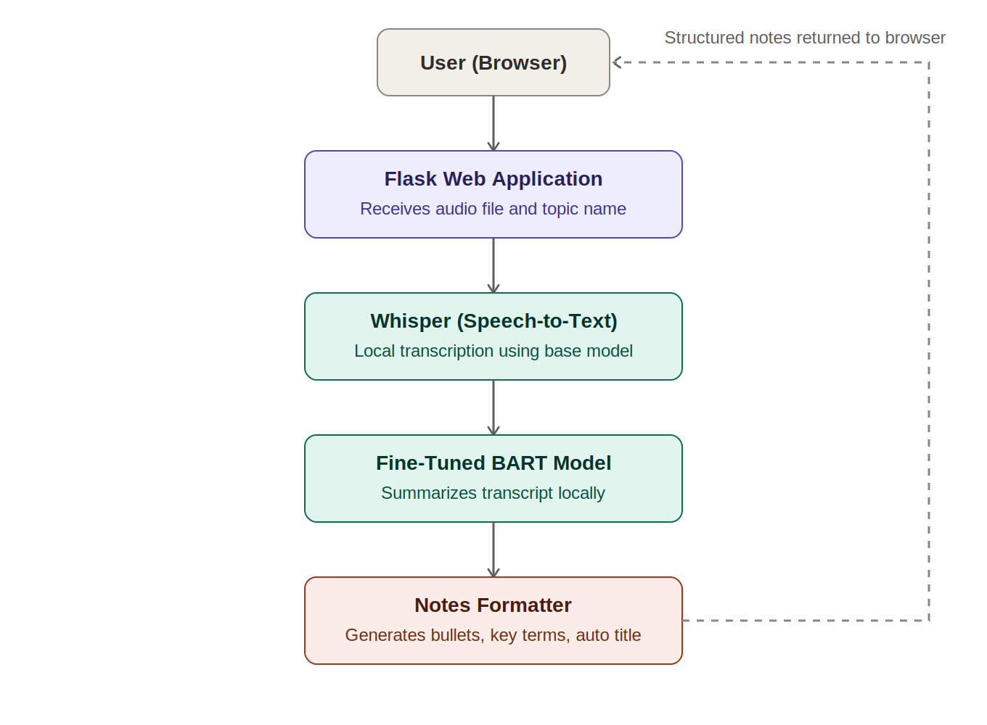
Figure 1: System architecture of the AI Lecture Notes Generator

13.1 Component Description

Flask Web Application (app.py)
This component serves the web interface and exposes two routes: a home route that renders the main page, and a /generate route that accepts an uploaded audio file and an optional topic name via an HTTP POST request. It coordinates the calls to the transcription, summarization, and formatting modules and returns the results as a JSON response.

Speech-to-Text Module (speech_to_text.py)
This module loads the Whisper base model once at startup and exposes a function that accepts an audio file path and returns the transcribed text. Whisper requires the FFmpeg multimedia framework to be installed and accessible on the system path in order to process audio files.

Summarizer Module (summarizer.py)
This module loads the fine-tuned BART model and tokenizer from the local finetuned-bart directory (produced by the fine-tuning script). It splits the input transcript into chunks based on sentence boundaries, with a maximum of approximately 120 words per chunk, and generates a summary for each chunk using beam search decoding before concatenating the results.

Notes Formatter Module (notes_formatter.py)
This module takes the combined summary text and a topic string (which may be empty) and produces a formatted notes string. If the topic string is empty, the module generates a title automatically by extracting the most meaningful words from the first sentence of the summary, filtering out common stop words. The module also splits the summary into individual bullet points and scans for the presence of predefined AI/ML key terms to display as tags.

Fine-Tuning Script (finetune.py)
This script is run separately (not as part of the live web application) to produce the fine-tuned BART model. It loads the custom dataset, tokenizes the input and target text pairs, and trains the model using the HuggingFace Trainer API across multiple epochs, saving the resulting model to the finetuned-bart directory.

Methodology
The project was developed iteratively over a period of approximately seven weeks, with each week focused on a specific phase of the system. This incremental approach allowed each component to be built, tested, and verified working before the next component was added, reducing the risk of compounding errors across multiple interdependent parts of the pipeline.
The development phases followed were:
- Environment setup: establishing a Python virtual environment and installing core dependencies (Flask, openai-whisper, transformers, torch).
- Speech-to-text implementation: integrating the Whisper base model and verifying transcription on a sample audio file.
- Summarization implementation: integrating the pre-trained facebook/bart-large-cnn model with basic chunking, and verifying summary output.
- Dataset preparation: constructing a custom dataset of twenty-five lecture-style text and summary pairs.
- Model fine-tuning: fine-tuning the BART model on the custom dataset using the HuggingFace Trainer API.
- Notes formatting: developing the module that converts raw summaries into structured notes with titles, key points, and key terms.
- Web interface development: building the Flask backend and HTML/CSS frontend, including drag-and-drop upload and results display.
- Polishing and refinement: fixing the sentence-chunking defect, adding automatic title generation, and improving the visual design.
At each phase, the working code was committed and pushed to a version-controlled repository hosted on GitHub, providing a complete historical record of the project's evolution.

Technologies Used
Technology / Tool | Purpose
Python 3 | Primary programming language used for all backend logic and model integration.
Flask | Lightweight Python web framework used to build the web application and serve the user interface.
OpenAI Whisper (local, base model) | Performs automatic speech recognition, converting lecture audio into text. Run entirely locally.
HuggingFace Transformers | Provides the BART model architecture, tokenizer, and the Trainer API used for fine-tuning.
facebook/bart-large-cnn | Pre-trained summarization model used as the base for fine-tuning.
PyTorch | Deep learning framework underlying both Whisper and the BART model.
FFmpeg | Multimedia framework required by Whisper for decoding audio files.
HTML, CSS, JavaScript | Used to build the front-end web interface, including drag-and-drop upload and results display.
Python venv | Used to create an isolated Python environment for the project's dependencies.
Git and GitHub | Used for version control and to host the project's source code repository.

15.1 Justification of Technology Choices
Python was chosen as the primary language due to its extensive ecosystem of machine learning libraries, including HuggingFace Transformers and PyTorch, both of which are essential for working with pre-trained and fine-tuned transformer models.
Flask was selected over alternative frameworks (such as Django) because of its lightweight nature, which is well suited to a project whose primary purpose is to expose a small number of API endpoints around an AI pipeline, rather than to provide a full content-management or database-driven application.
A standard Python virtual environment (venv) was used in preference to Anaconda. While Anaconda is well suited to data science workflows involving Jupyter notebooks and complex scientific package management, the dependencies required for this project (Flask, Whisper, Transformers, and PyTorch) are all readily available via pip, making a lightweight venv environment more appropriate and avoiding potential package conflicts.

Database Design
This project does not use a database. All processing is performed in a stateless manner: an uploaded audio file is temporarily saved to a local uploads directory for the duration of processing, and is deleted automatically once the transcription, summarization, and formatting steps are complete. Generated notes are returned directly to the user's browser and are not persisted on the server.
This design decision was made deliberately to keep the scope of the project focused on the artificial intelligence pipeline, which was the primary learning objective of the course. A future enhancement, discussed in the Future Enhancements section of this report, would be to introduce a lightweight database (such as SQLite) to allow users to save and revisit previously generated notes.

User Interface Design
The user interface was designed with simplicity and clarity as the primary goals, reflecting the project's emphasis on functionality over visual complexity. The interface consists of a single page divided into three main sections: an input section, a loading-state section, and a results section.

17.1 Input Section
The input section contains a text field where the user may optionally enter a topic name, and a drag-and-drop area where the user can either drag an audio file directly onto the page or click a "Browse File" button to select a file using the operating system's file picker. Below this is a single "Generate Notes" button that initiates processing.

17.2 Loading State
While the audio file is being processed, the input section is replaced by a loading indicator consisting of an animated spinner and a rotating status message ("Transcribing audio...", "Summarizing content...", "Formatting notes...") to keep the user informed of the system's progress, since processing can take a noticeable amount of time on a standard laptop.

17.3 Results Section
Once processing is complete, the results section displays the full transcript of the audio (for reference) and the structured notes, which include the topic title, a bulleted list of key points, and a list of key terms relevant to the lecture content. An "Export" button allows the user to download the notes as a plain text file.

17.4 Visual Design
The interface uses a purple and white colour scheme, with a header bar identifying the application, rounded card-style containers for each section, and a footer crediting the underlying technologies (Whisper and BART). The design avoids unnecessary visual clutter, focusing the user's attention on the upload action and the resulting notes.
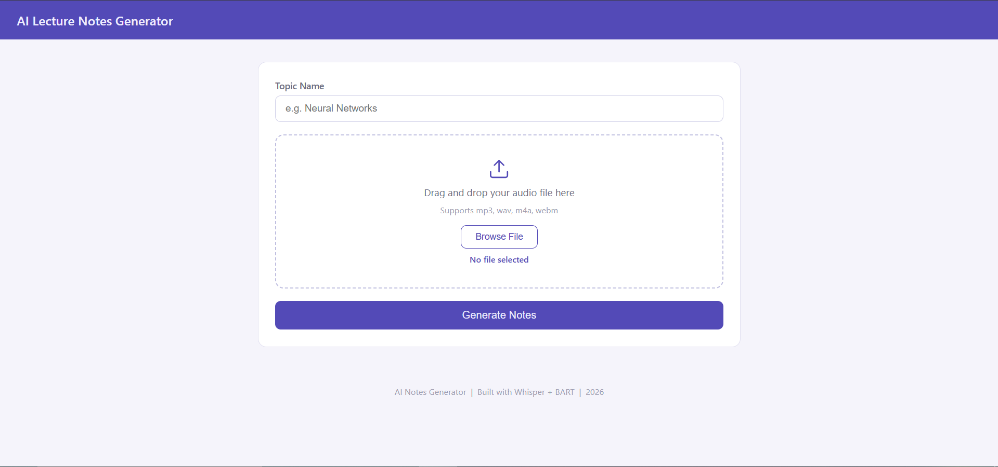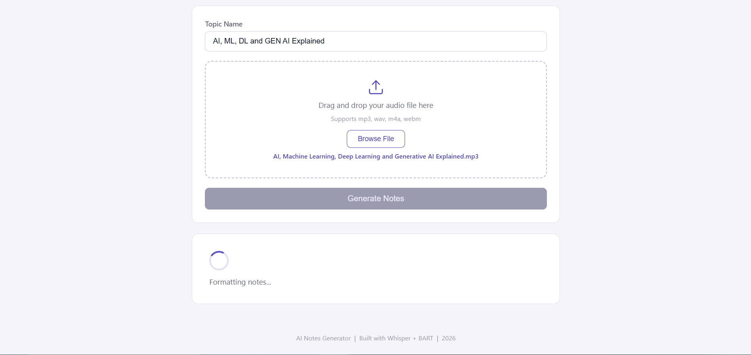

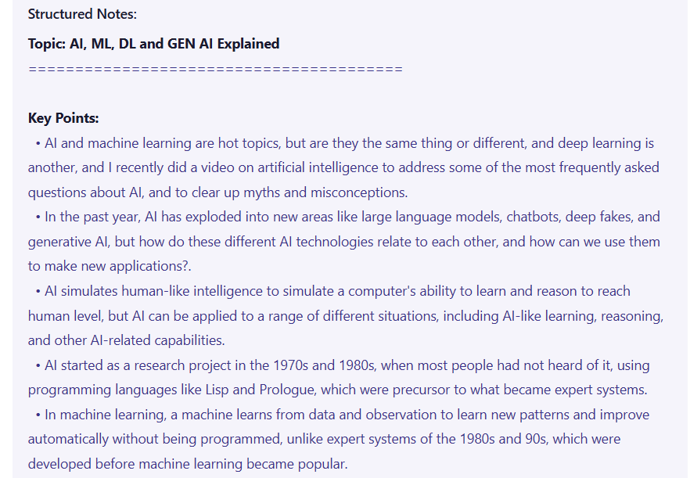

Project Workflow
Figure 2 illustrates the end-to-end workflow from the perspective of the user, beginning with opening the application and ending with the display of structured notes that can be exported.
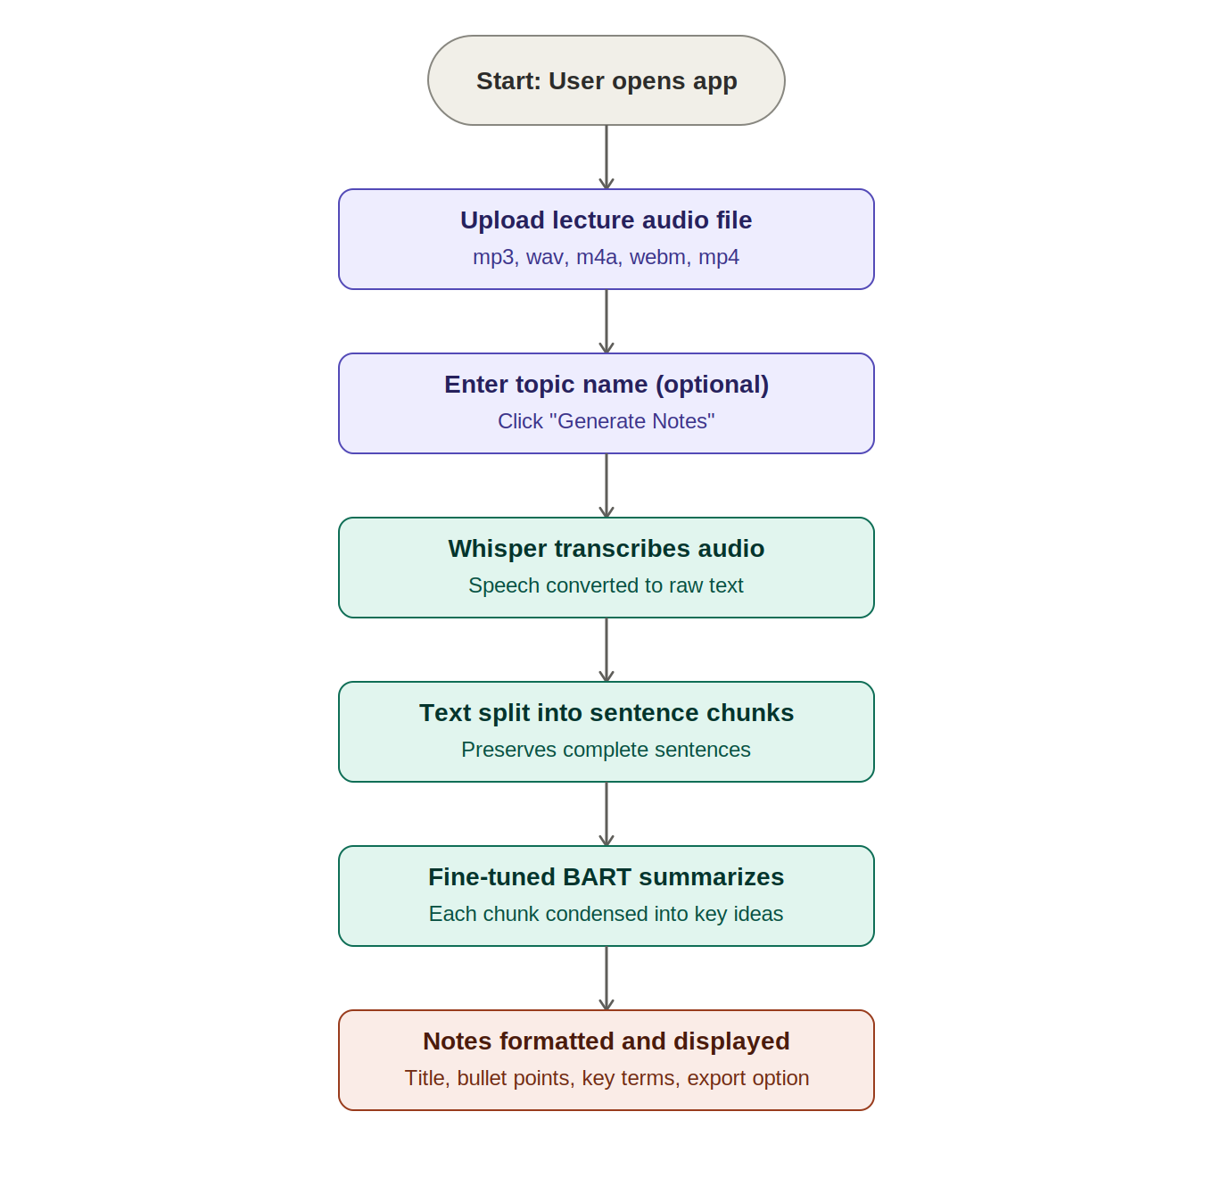
Figure 2: User workflow of the AI Lecture Notes Generator

18.1 Use Case Diagram
Figure 3 presents a use case diagram summarizing the interactions available to the primary actor (the student or user) within the system.
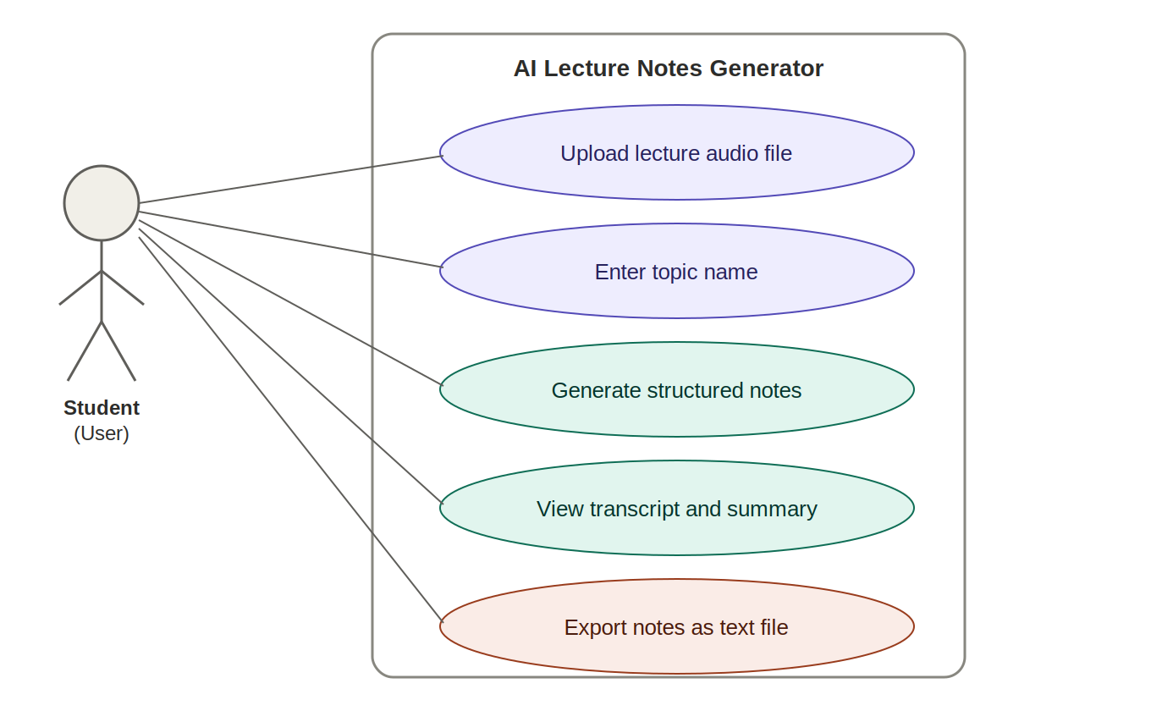
Figure 3: Use case diagram for the AI Lecture Notes Generator

AI Integration and How the AI Works
Two artificial intelligence models form the core of this project: OpenAI's Whisper model for speech recognition, and a fine-tuned version of Facebook's BART model for text summarization. This section explains how each model works and, in particular, how the BART model was fine-tuned -- the central training component of this project.

19.1 Speech Recognition with Whisper
Whisper is a transformer-based encoder-decoder model trained by OpenAI on a large corpus of audio paired with transcripts. In this project, the open-source Whisper Python package is used to load the "base" model size locally. When an audio file is provided, Whisper processes the audio in segments, using its encoder to convert audio features into an internal representation and its decoder to generate the corresponding text, one token at a time. The output is a complete text transcript of the spoken content, including punctuation.
No training was performed on the Whisper model in this project; it is used directly in its pre-trained form, as permitted because the training component of the project requirement was satisfied through the fine-tuning of the BART summarization model, described next.

19.2 Summarization with Fine-Tuned BART
BART is a sequence-to-sequence transformer model: it reads an input sequence of text using a bidirectional encoder and generates an output sequence of text using an auto-regressive decoder. The pre-trained facebook/bart-large-cnn model was originally trained to summarize news articles. While capable of producing grammatically correct summaries of any English text, its output style reflects the news domain it was originally trained on.
To adapt this model to the domain of artificial intelligence lecture content, the model was fine-tuned using a custom dataset consisting of twenty-five examples, each containing an input_text field (a paragraph of AI lecture content) and a target_text field (a concise, hand-written summary of that paragraph). Eighteen of these examples were derived from the author's own AI course lecture material, covering topics such as machine learning, supervised and unsupervised learning, reinforcement learning, agents and environments, reasoning, the Turing Test, and the distinction between weak and strong AI. The remaining seven examples were generated to cover additional foundational AI/ML topics -- including neural networks, deep learning, natural language processing, decision trees, overfitting and underfitting, gradient descent, and transfer learning -- ensuring the dataset provided broad coverage of terminology relevant to AI coursework.

19.2.1 Fine-Tuning Process
The fine-tuning process, implemented in finetune.py, followed these steps:
- The dataset was loaded from a JSON file and split into a training set (80% of examples) and a test/evaluation set (20% of examples).
- Each example was tokenized using the BART tokenizer, converting both the input text and the target summary into numerical token sequences, with padding and truncation applied to fixed maximum lengths (512 tokens for input, 128 tokens for target).
- A custom PyTorch Dataset class was implemented to serve these tokenized examples to the training loop, with padding tokens in the labels replaced by the value -100 so that the loss function ignores them during training.
- The HuggingFace Trainer API was configured with training arguments specifying three training epochs, a batch size of two, weight decay for regularization, and an evaluation and model-saving strategy executed after each epoch.
- The Trainer was run, fine-tuning the model's weights over the three epochs while periodically evaluating performance on the held-out test examples and printing the training loss, which decreased over successive epochs -- indicating that the model was learning to better approximate the target summaries.
- The resulting fine-tuned model and tokenizer were saved to a local directory (finetuned-bart), which is loaded by the summarizer module at runtime.

19.2.2 Verification of Fine-Tuning
To verify that fine-tuning had an effect, the fine-tuned model was tested on a paragraph about deep learning that was not part of the training dataset. The model produced a single, coherent sentence that accurately condensed the five-sentence input paragraph, retaining the key concepts (multiple layers, neural networks, learning features from raw data) while removing redundant phrasing -- demonstrating that the model had learned to produce concise, lecture-appropriate summaries.

19.3 Sentence-Aware Chunking
Because BART models have a maximum input length (512 tokens in this implementation), long transcripts must be divided into smaller chunks before summarization. The summarizer module implements a sentence-aware chunking algorithm: rather than splitting the transcript at a fixed character count (which can cut sentences in half), the algorithm first splits the transcript into individual sentences using a regular expression that detects sentence-ending punctuation, then groups consecutive sentences together until a chunk reaches approximately 120 words, ensuring that no chunk ends mid-sentence. Each chunk is summarized independently, and the resulting summaries are concatenated to form the final summary text.

19.4 Automatic Title Generation
The notes formatter module includes a function that generates a topic title automatically when the user does not supply one. This function extracts the first sentence of the generated summary, removes common English stop words (such as "the", "is", "and", "what"), and takes the first five remaining words, formatting them in title case. For example, given a summary beginning with the sentence "If there is one thing to unite this world, it is the hatred of small talk", the function produces the title "Small Talk Can Terrible Scary" -- a concise, if imperfect, indication of the lecture's subject matter, generated entirely through rule-based natural language processing without requiring an additional model call.

Challenges Faced During Development
As with most software projects, the development of the AI Lecture Notes Generator involved a number of technical challenges. This section documents the most significant of these challenges, along with the solutions applied to resolve them. Documenting these issues serves not only as a record of problem-solving but also reflects the practical, hands-on learning that occurred throughout the project.

20.1 Mid-Course Requirement Change: From APIs to Local Training
The project was originally planned around external APIs, including the Claude API for summarization and the OpenAI Whisper API for transcription. Partway through development, the course instructor introduced a requirement that students must train their own models. This required a significant redesign of the project's architecture, shifting from a cloud-API-based design to a fully local pipeline.
Resolution: After considering the available options -- including training a model entirely from scratch, or running a pre-trained local model such as Llama via Ollama -- the decision was made to fine-tune the existing facebook/bart-large-cnn model on a custom dataset. This approach was selected because it represented a realistic and achievable training task for a fourth-semester student, while still constituting genuine model training rather than simply consuming a pre-trained model unchanged.

20.2 Virtual Environment Path Errors After Moving the Project Folder
After the project folder was moved to a different location on disk, attempts to install Python packages using pip failed with a "Fatal error in launcher" message, because the virtual environment's executable scripts contained hard-coded references to the original folder path.
Resolution: The broken virtual environment was deleted and recreated in the new location using python -m venv venv, after which all required packages were reinstalled. This experience highlighted the importance of finalizing a project's folder location before creating its virtual environment.

20.3 Shell Inconsistencies Between PowerShell and Command Prompt
Several command-line operations -- including deleting a directory and activating the virtual environment -- behaved differently or failed outright depending on whether the terminal was running PowerShell or Command Prompt (CMD). For example, the CMD command rd /s /q venv is not a valid PowerShell command, and PowerShell's script execution policy initially blocked the virtual environment activation script.
Resolution: The project standardized on using Command Prompt (CMD) for all terminal operations, which avoided the script execution policy restrictions of PowerShell and ensured that commands documented in the project's README behaved consistently.

20.4 Deprecated Training Argument in HuggingFace Transformers
When first running the fine-tuning script, a TypeError was raised because the evaluation_strategy argument used in the TrainingArguments configuration had been deprecated and renamed in the installed version of the transformers library.
Resolution: The deprecated argument evaluation_strategy was replaced with its current equivalent, eval_strategy, after which the fine-tuning script ran successfully.

20.5 Sentence Truncation in Generated Notes
In an early version of the system, the summarizer split long transcripts into chunks of a fixed number of characters (500) before passing each chunk to the BART model. Because this split point did not respect sentence boundaries, some chunks began or ended in the middle of a word or sentence, resulting in structured notes containing bullet points such as "poral lobe is a key structure..." (a truncated form of "temporal lobe") and "ain cells in the hippocampus..." (a truncated form of "brain cells").
Resolution: The chunking algorithm in the summarizer module was rewritten to first split the transcript into complete sentences using a regular expression based on sentence-ending punctuation, and then to group these complete sentences into chunks of approximately 120 words. This ensured that every chunk -- and therefore every generated summary sentence -- began and ended at a genuine sentence boundary, eliminating the truncation issue.

20.6 Large Model Files in Version Control
The fine-tuned BART model, saved to the finetuned-bart directory, is several gigabytes in size. Attempting to commit this directory to the Git repository caused the git add command to run for an extremely long time, effectively appearing to hang.
Resolution: The finetuned-bart directory (along with the virtual environment, the sample audio file, and Python cache files) was added to a .gitignore file, excluding it from version control. To ensure the project remained reproducible, the README file was updated to include instructions for regenerating the fine-tuned model locally by running the fine-tuning script -- a common practice in real-world machine learning repositories, where trained model weights are typically not stored directly in source control.

20.7 Auto-Generated Title Not Triggering
After implementing the automatic title generation feature in the notes formatter module, testing showed that the generated notes always displayed "Lecture Notes" as the title, even when the topic field was left empty, suggesting the automatic title generation logic was never being triggered.
Resolution: Investigation traced the issue to the frontend JavaScript code, which used the expression document.getElementById('topic').value || 'Lecture Notes' when preparing the data to send to the server. This expression substituted the default string "Lecture Notes" whenever the topic field was empty, before the request was even sent -- meaning the backend never received an empty string and therefore never triggered the automatic title generation logic. The fix involved removing this default substitution on the frontend, allowing an empty topic value to be sent to the server, where the notes formatter module's existing logic correctly detected the empty string and generated a title automatically based on the content.

20.8 Browser Caching During Frontend Development
On several occasions during frontend development, changes made to the HTML, CSS, or JavaScript files did not appear to take effect when the page was reloaded in the browser, even after the Flask server was restarted.
Resolution: This was identified as a browser caching issue. Performing a hard refresh (Ctrl+Shift+R) or clearing the browser cache resolved the issue, and testing in a different browser confirmed that the underlying code changes had in fact been applied correctly.

Testing and Validation
Testing of the AI Lecture Notes Generator was conducted incrementally, with each pipeline component validated independently before being integrated into the complete system. This approach reflects standard practice in machine learning system development, where isolating each stage of a pipeline makes it considerably easier to identify the source of any unexpected output.

21.1 Speech-to-Text Validation
The speech-to-text module was tested using a sample MP3 audio file (a recorded talk on the topic of exercise and brain health, used as a convenient test input not related to the AI subject matter). The module successfully produced a complete and accurate text transcript of the audio, including correctly punctuated sentences, confirming that the Whisper base model was functioning correctly within the local environment.

21.2 Summarization Validation
Prior to fine-tuning, the pre-trained facebook/bart-large-cnn model was tested on the sample transcript and produced grammatically correct but somewhat generic summaries. After fine-tuning, the model was tested on a held-out paragraph about deep learning that was not included in the training dataset. The fine-tuned model produced a single, accurate sentence summarizing the five-sentence input, demonstrating that the fine-tuning process had successfully adjusted the model's summarization behaviour.

21.3 Notes Formatter Validation
The notes formatter module was tested independently using a standalone test script (run via python notes_formatter.py), which verified both the manual-topic path (where a user-supplied topic such as "Neural Networks" is used directly as the title) and the automatic-title path (where, given the same summary text but an empty topic string, the module correctly generated the title "Neural Networks Mimic Human Brain").

21.4 End-to-End Pipeline Validation
The complete pipeline was tested by running main.py, which chains together the speech-to-text, summarization, and notes-formatting modules and processes the sample audio file from start to finish. This test confirmed that data passed correctly between all three modules and that the final output was a well-formed structured notes string.

21.5 Web Application Validation
The Flask web application was tested by running the application locally and accessing it through a web browser at the address http://127.0.0.1:5000. Testing included uploading the sample audio file with and without a specified topic name, verifying that the loading indicator displayed correctly during processing, that the transcript and structured notes were displayed correctly upon completion, and that the export function correctly downloaded the notes as a text file. Testing was also performed across two different web browsers to rule out browser-specific caching issues, as discussed in the Challenges section.

21.6 Defect Verification
After the sentence-chunking fix described in the Challenges section was applied, the end-to-end pipeline was re-tested using the same sample audio file. The resulting structured notes contained complete, grammatically coherent sentences in every bullet point, with no instances of the mid-word truncation observed prior to the fix -- confirming that the defect had been successfully resolved.

Results and Output
The completed AI Lecture Notes Generator successfully fulfills all functional requirements identified earlier in this report. Given an audio recording of a lecture or talk, the system produces a complete text transcript, a condensed summary generated by a model fine-tuned specifically for this purpose, and a set of structured notes consisting of a topic title, a bulleted list of key points, and a list of relevant key terms.
An example output, generated from a recorded talk on the topic of small talk and communication skills (used as a test input), is shown below. With the topic field left empty, the system automatically generated the title "Small Talk Can Terrible Scary" based on the content of the summary, and produced twenty-six bullet points covering the main ideas discussed in the talk, including the difference between open-ended and closed-ended questions, a formula for initiating conversation, and advice on body language at networking events.
When the same audio is processed with a manually specified topic (for example, "Neural Networks"), the system uses the supplied topic directly as the title, demonstrating that both the manual and automatic title generation paths function correctly.

22.1 Sample of Fine-Tuning Results
During fine-tuning, the training loss was observed to decrease across the three training epochs, indicating that the model was successfully learning from the custom dataset. When tested on an unseen paragraph describing deep learning, the fine-tuned model produced the following summary:
"Deep learning uses multiple layers of neural networks to learn features from raw data, revolutionizing computer vision, speech recognition, and natural language processing."
This single, coherent sentence accurately captures the key information from the original five-sentence input paragraph, demonstrating the practical effect of the fine-tuning process.

22.2 Project Repository

The complete source code for this project, including the dataset, fine-tuning script, and web application, is publicly available on GitHub at: github.com/abdullaahadnann/Ai-Lecture-Notes-Generator

Screenshots with Explanations
This section presents screenshots of the working application. Each screenshot is accompanied by a brief explanation of what is shown.

23.1 Main Interface (Input Section)
The main interface presents the user with a topic name field (optional), a drag-and-drop area for uploading an audio file, and a "Generate Notes" button. The interface uses a clean purple and white design with a header identifying the application.

23.2 Loading State
While the uploaded audio is being processed, the interface displays an animated spinner along with a status message that cycles between "Transcribing audio...", "Summarizing content...", and "Formatting notes..." to indicate progress to the user.

23.3 Generated Notes (Manual Topic)

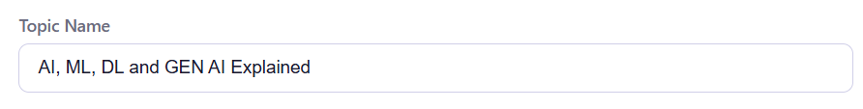
When a topic name (for example, "Neural Networks") is supplied by the user, the generated notes display this topic as the title, followed by the transcript, a bulleted list of key points extracted from the summary, and a list of detected key terms such as "Neural Network", "Deep Learning", and "Backpropagation".

23.4 Generated Notes (Automatic Title)
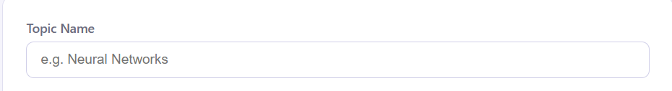

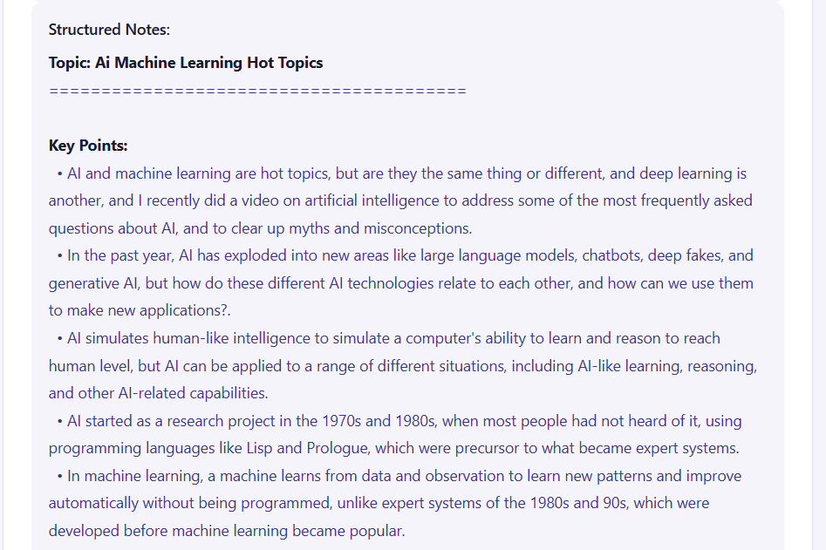
When the topic field is left empty, the system automatically generates a relevant title based on the content of the summary, demonstrating the automatic title generation feature described in Section 19.4.

23.5 Export Function
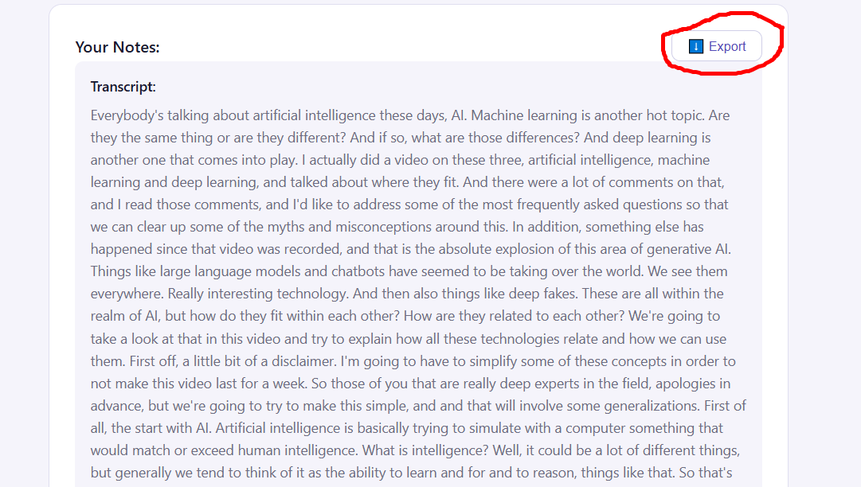Clicking the "Export" button downloads the generated notes as a plain text (.txt) file, which can be opened in any text editor or imported into note-taking applications.

23.6 Project Repository on GitHub
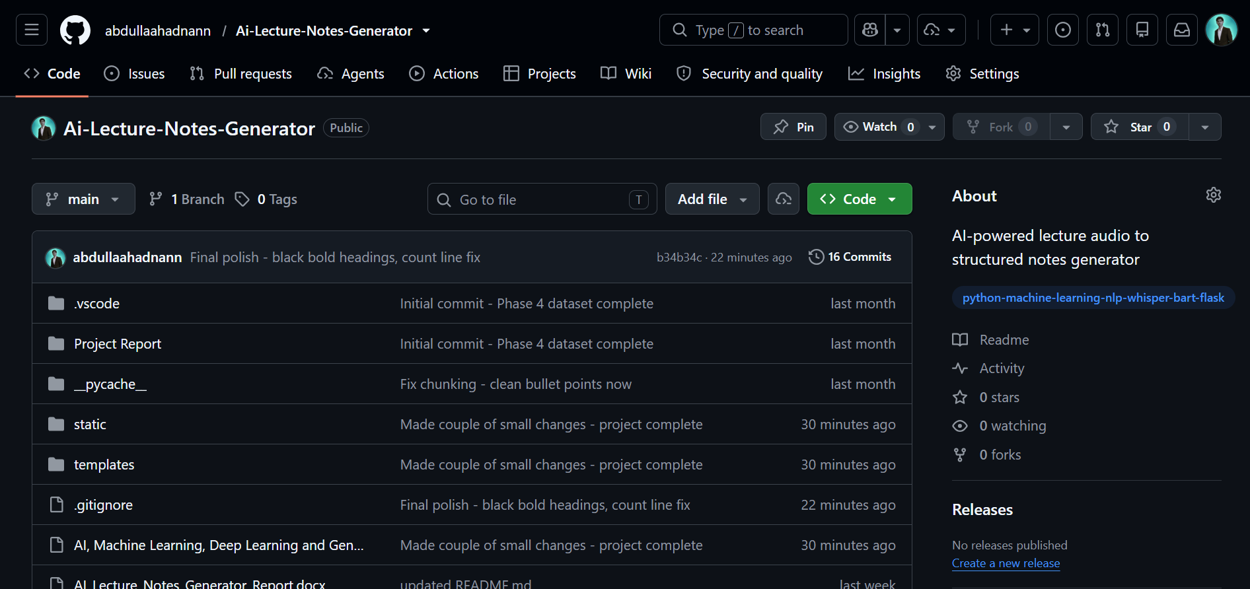The project's GitHub repository contains the complete, version-controlled source code, a README file describing the project and providing setup instructions, and a .gitignore file excluding large model files and environment-specific directories from version control.

Future Enhancements
While the current implementation satisfies all of the project's original objectives, several enhancements could extend its functionality and usefulness in future iterations:
- Expanded training dataset: Increasing the size and diversity of the fine-tuning dataset beyond twenty-five examples, potentially covering multiple subjects beyond artificial intelligence, would likely improve the quality and generality of generated summaries.
- Persistent storage: Introducing a lightweight database (such as SQLite) would allow users to save, browse, and revisit previously generated notes across sessions.
- Additional export formats: Supporting export to PDF or Word document formats, in addition to plain text, would make the generated notes more directly usable for study and sharing.
- Improved automatic title generation: Replacing the current rule-based stop-word-filtering approach with a small fine-tuned sequence-to-sequence model specifically trained for title generation could produce more grammatically natural titles.
- Support for larger Whisper models: Allowing the user to select between Whisper model sizes (e.g. small, medium) would let users trade off transcription speed against accuracy depending on their hardware.
- Multi-language support: Extending the fine-tuning dataset and leveraging Whisper's multilingual capabilities would allow the system to process lectures delivered in languages other than English.
- Real-time transcription: Adding support for processing audio as it is being recorded, rather than only after a complete file has been uploaded, would enable live note-taking during a lecture.

Conclusion
This project set out to design and build a system capable of converting recorded lecture audio into structured, useful notes, while satisfying an academic requirement to train a custom artificial intelligence model rather than rely on external commercial APIs. Both goals were achieved.
The resulting AI Lecture Notes Generator integrates a locally-run Whisper model for speech recognition with a BART summarization model that was fine-tuned by the author on a custom dataset of twenty-five lecture-style text and summary pairs. This fine-tuning process represents genuine, hands-on application of the transfer learning concepts covered in the Artificial Intelligence course, and its effectiveness was demonstrated through testing on unseen text. The addition of a custom notes-formatting module, including an automatic title-generation feature, further extends the system's usefulness beyond a simple summarization tool, producing output that closely resembles notes a student might write by hand.
Throughout development, the project encountered and resolved a range of practical software engineering challenges, including environment configuration issues, version control difficulties with large model files, and a sentence-truncation defect in the text-chunking logic. Each of these challenges was diagnosed, addressed, and verified through testing, reflecting an iterative and methodical development process.
Ultimately, this project demonstrates that a complete, locally-executable artificial intelligence pipeline -- encompassing speech recognition, custom model fine-tuning, natural language processing, and full-stack web development -- can be designed, implemented, and delivered by a single fourth-semester student. The skills developed and demonstrated through this project, particularly around model fine-tuning, dataset preparation, and pipeline debugging, form a strong foundation for further study and application of artificial intelligence techniques.

References
[1] Radford, A., Kim, J. W., Xu, T., Brockman, G., McLeavey, C., & Sutskever, I. (2022). Robust Speech Recognition via Large-Scale Weak Supervision. OpenAI. Available at: https://github.com/openai/whisper
[2] Lewis, M., Liu, Y., Goyal, N., Ghazvininejad, M., Mohamed, A., Levy, O., Stoyanov, V., & Zettlemoyer, L. (2019). BART: Denoising Sequence-to-Sequence Pre-training for Natural Language Generation, Translation, and Comprehension. Facebook AI Research.
[3] HuggingFace. Transformers Documentation. Available at: https://huggingface.co/docs/transformers
[4] HuggingFace. facebook/bart-large-cnn Model Card. Available at: https://huggingface.co/facebook/bart-large-cnn
[5] Pallets Projects. Flask Documentation. Available at: https://flask.palletsprojects.com
[6] FFmpeg Project. FFmpeg Documentation. Available at: https://ffmpeg.org
[7] Project source code repository: https://github.com/abdullaahadnann/Ai-Lecture-Notes-Generator

